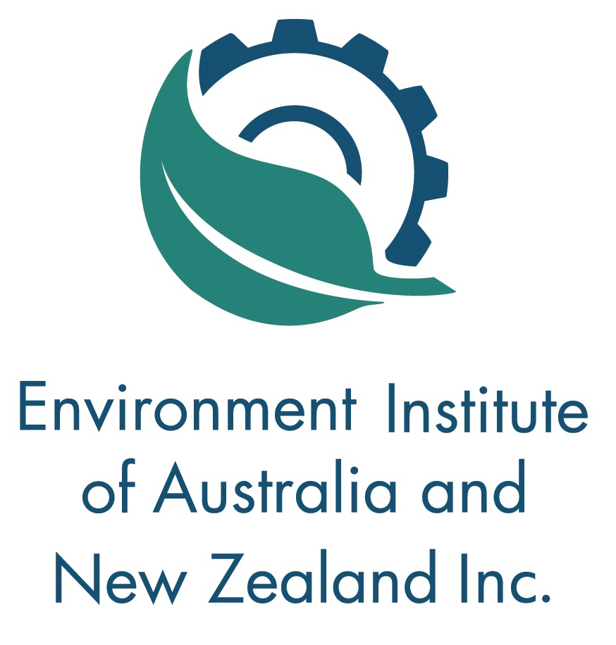
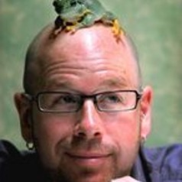
Review of the State of the Environment Report for South Australia

Join us as invited reviewer of the SA EPA's State of the Environment Report for Terrestrial Biodiversity.

Guest Speaker Corey Bradshaw discusses his findings.

When: | Thursday, 21st March 2019
Time: | 4:30pm to 7:00pm
Where: | Department for Energy and Mining,  Level 4 / 11 Waymouth Street  Adelaide SA 5000
Cost: | EIANZ Members: $20  Non-members: $40  EIANZ Student Members: Free
RSVP: | Wednesday, 20th March 2019
Contact: | office@eianz.org

MEET THE SPEAKER
Corey Bradshaw

I joined Flinders University in January
2017 as the Matthew Flinders Fellow in
Global Ecology. I am the Director of
the Global Ecology Laboratory and a
Chief Investigator in the ARC Centre of
Excellence for Australian Biodiversity and Heritage, and I lead its Modelling Node here at Flinders.

From 2008-2015 I was at the University of Adelaide (Sir Hubert Wilkins Chair of Climate Change2015-2016), and from 2004-2008 I was Senior then Principal Research Fellow at Charles Darwin University. I was an ARC Postdoctoral Fellow at the University of Tasmania from 1999-2004.

My research is mainly in the area of global-change ecology — how human endeavour and climate fluctuations have altered past, present and future ecosystems. My most important contributions have been in the area of applied ecology, biodiversity conservation, theoretical ecology, extinction dynamics, human demography, species responses to climate change, disease ecology, and applying ecological theory and modelling techniques to hindcast prehistoric ecosystems. My work has provided environmental policy advice around the world, and my papers are highly cited.

SA Division

Environment Institute of Australia and New Zealand

<Division Name>

